Developing needs
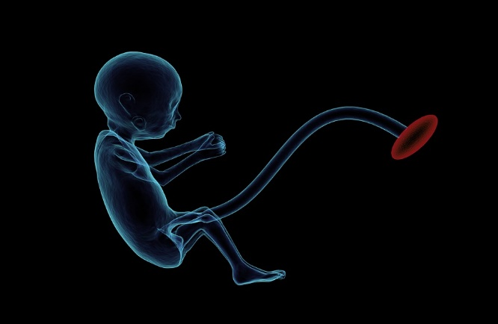

As a fetus grows and develops in the uterus it must be provided with substances it needs to stay alive and the materials needed for growth.
Look at the statements in the table. Some are right and some are wrong.
Tick one box for each statement.

Statements |  | I am sure this is right | I think this is right | I think this is wrong | I am sure this is wrong
1 | The mother’s blood takes nutrients to the developing fetus.
2 | The fetus breathes in amniotic fluid.
3 | Amniotic fluid contains the oxygen a fetus needs to survive.
4 | The baby produces urine which it releases into the amniotic fluid.
5 | To keep warm the fetus must move around.

Biology > Big idea: Heredity and life cycles > Topic BHL3: Reproduction > Key concept BHL3.1: Sexual reproduction in humans
Diagnostic question
Developing needs

Overview
Learning focus: | The human male and female reproductive systems produce and release gametes which come together during sexual reproduction, and if an ovum is fertilised by a sperm a fetus develops in the uterus of the female.
Observable learning outcome: | Describe the role of the umbilical cord, placenta and amniotic fluid in fetal development.
Question type: | Confidence grid
Key words: | amniotic fluid, placenta, umbilical cord, fetus, pregnancy, gestation, reproduction

What does the research say?
It would seem that children have a desire to know more about the development of the embryo and fetus following conception and implantation. Children participating in Zimvrakaki (2004) research into children’s representations about their body and sexual development requested more information about the reproductive system and the development of the embryo, listing information on how the embryo breaths and gets air as being one area where they felt their knowledge was lacking.
Franse et al. (2009) conducted a study on children’s thoughts on unborn babies, and noted that literature on children’s preconceptions on fetal development is scarce. Their study examines whether children have a coherent, naïve theory or fragmented knowledge of prenatal development, and concludes that children have a more coherent theory for changing morphology than for changing bodily function, with the latter being more fragmented. Topics investigated in the bodily function aspect of the research related to breathing, drinking and maintaining body temperature.
Ways to use this question
Students should complete the confidence grid individually. This could be a pencil and paper exercise, or you could use the presentation with an electronic voting system or mini white boards.
Differentiation
You may choose to read the question to the class, so that everyone can focus on the science. In some situations it may be more appropriate for a teaching assistant to read for one or two students.
Expected answers
- The mother’s blood takes nutrients to the developing fetus – wrong
- The fetus breathes in amniotic fluid – right (in later pregnancy)
- Amniotic fluid contains the oxygen a fetus needs to survive – wrong
- The baby produces urine which it releases into the amniotic fluid – right
- To keep warm the fetus must move around – wrong
How to respond - what next?
If there is a range of answers, you may choose to respond through structured class discussion. Ask one student to explain why they gave the answer they did; ask another student to explain why they agree with them; ask another to explain why they disagree, and so on. This sort of discussion gives students the opportunity to explore their thinking and for you to really understand their learning needs. Responses often work best when the activities involve paired or small group discussions, which encourage social construction of new ideas (meaning making) through dialogue.
This activity will identify if students have any misunderstandings about the role of the placenta, umbilical cord and amniotic fluid in meeting the needs of the developing fetus. Research has identified that whilst students seem to grasp the changes in morphology during development, they appear to know less about the changing bodily functions and this in part could be due to a lack of understanding of the functions of the placenta, umbilical cord and amniotic fluid.
Many students believe that the mother’s blood mixes with the fetal blood to provide the nutrients required, and do not appreciate that the blood does not mix; instead the placenta facilitates this exchange. Statement 1 will identify if there is confusion in this area. Many students are not aware that the haemoglobin found in fetal red blood cells is different to that of maternal blood cells, and it is this difference in affinity that allows the fetal blood to effectively remove the oxygen from the maternal blood.
Many students are aware of the role of the amniotic fluid in protection of the fetus, but do not realise that in later pregnancy the fetus will in fact breathe in some of this fluid; it is not, however, using it to obtain oxygen. An incorrect response to statement 3 will identify this misunderstanding. Students are also often not aware that the fetus will excrete some urine into the fluid or that it is the fluid that maintains the temperature of the fetus. Statements 4 and 5 will identify any misunderstandings about these functions.
If students have misunderstandings about the role of the placenta and amniotic fluid, it would be advisable to spend some time studying a diagram to show the developing fetus in the uterus and the associated structures. A more detailed diagram of the placenta and umbilical cord will be of greater use as students may need an explanation as to how the blood of the two individuals is not mixed, yet the essential nutrients, oxygen, and antibodies are able to pass from mother to fetus via the umbilical cord. The placenta and fetus are connected by the umbilical cord.
The following BEST ‘response activity’ could be used in follow-up to this diagnostic question:
- Response activity: A new life
Acknowledgments
Developed by Elizabeth Lupton (UYSEG).
Images: pixabay.com/sbtlneet (1788082)
References
Franse, R. R., Maartje., Van Es, S. E. and Van Schijndel, T. J. P. (2009). Children's thoughts on unborn babies. Representational redescription in preconceptions of children on fetal development. Proceedings of the Annual Meeting of the Cognitive Science Society, 31(31).
Zimvrakaki, E. and Athanasiou, K. (2004). Children's representations about their body and sexual development. ERIDOB. Patras- Greece: Patras University Press.

